Steps on how to download the PDF format

- Once you have accessed the course, you will see the screen below:
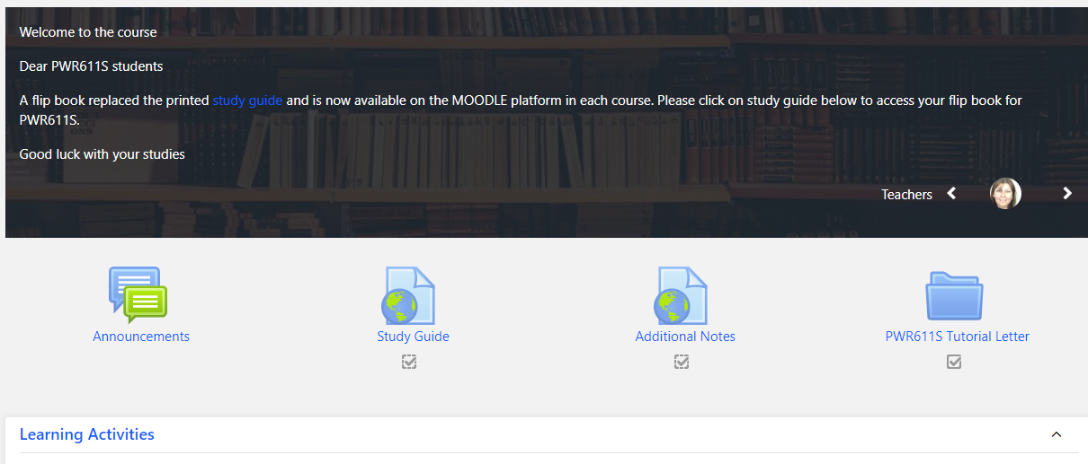

- Click on Study Guide and the flip book will open in a new window as per the screenshot below:
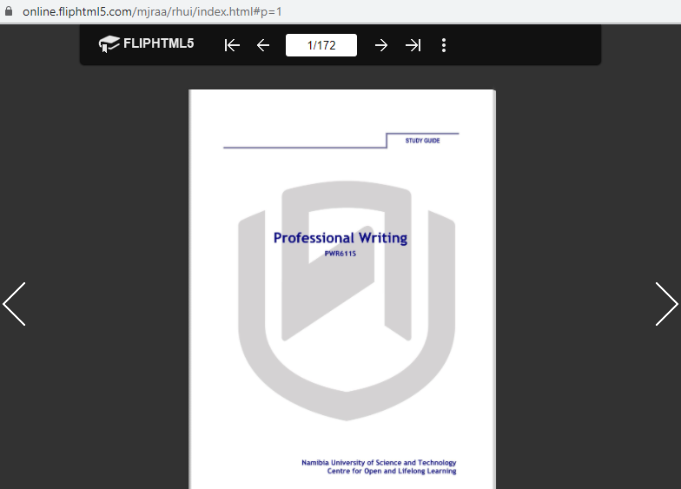

- Continue to click on “more” and this screen will appear:
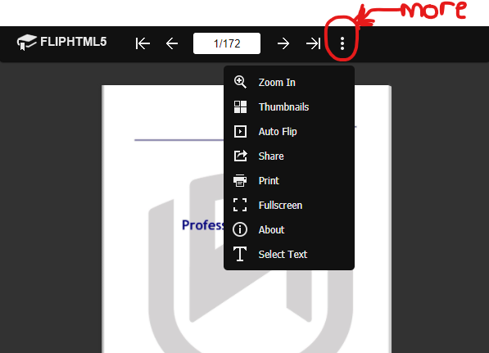
Click on share and you will see the screen below:
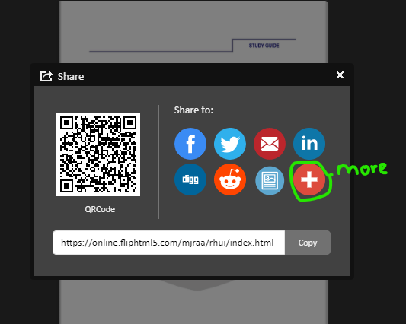
- Click on more, then the screen below will appear.
Here, you have an option to either share via WhatsApp/WeChat or you can type “PDF” in the search space.
- If you opt for WhatsApp/WeChat, the QRCode will appear and you can scan it with your phone, and the flip book will open in your phone.
- However, if you choose PDF, the second screen will appear. Click on “PDFmyURL”, then it will take you another page.
First screen
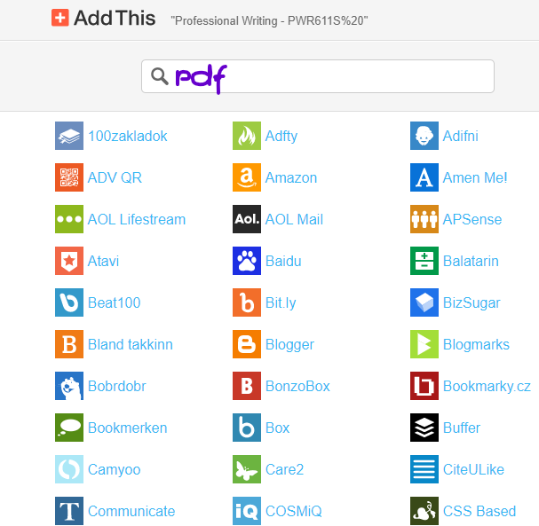
Second screen
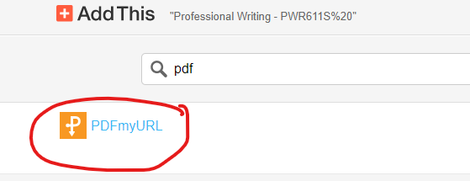
- This screen will appear once you click on PDFmyURL. The contacting PDFmyURL drop down Menu option will now appear. Click on it to open.

- The pdf format will open in a new window. Click on “download” on the right hand side to download the PDF format as shown in the screenshot below.
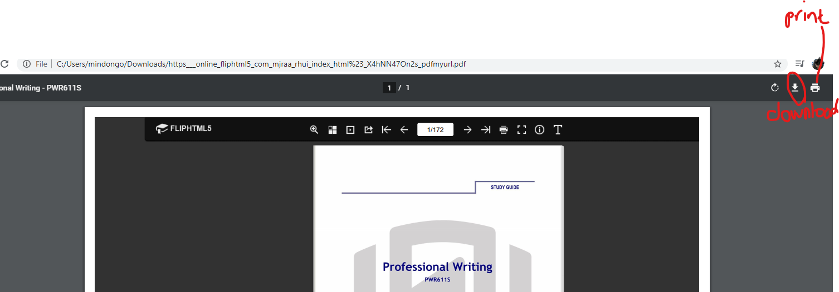

- You have successfully downloaded your PDF document.

NOTE:
YOU MAY NOW OPT TO PRINT THE PDF STUDY GUIDE THAT YOU HAVE DOWNLOADED. NASHUA IN Windhoek at the Main Campus provide this service to you at a cost of N$100.00.

